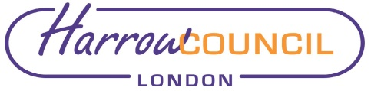
Report for: | Cabinet
Date of Meeting: | 24th May 2022
Subject: | 1 hour free on street parking
Key Decision: | No
Responsible Officer: | Dipti Patel - Corporate Director Place;  Tony Galloway - Director of Environment
Portfolio Holder: | Councillor Anjana Patel - Portfolio Holder for Environment & Community Safety
Exempt: | No
Decision subject to Call-in: | Yes

Section 1 – Summary and Recommendations
This report sets out proposals for introducing free one hour parking in paid for parking bays across the borough. Authority is sought to develop options to be brought to a future meeting of Cabinet.

Recommendations:
Cabinet is requested to:
- Instruct officers to develop costed options to deliver free one hour parking in paid for parking bays across the borough and bring a further report to the meeting of Cabint in June; and
- Agree that if necessary the Leader determine the prefered option for implementation.

Reason: (for recommendations)
Consideration of one-hour free parking is being recommended to assist the recovery of local businesses in the borough following the pandemic.

Section 2 – Report

Introductory paragraph
Following the pandemic local businesses are in recovery and require support. In addition to all the other projects the Council is offering to support the local high streets, this report seeks authority to explore a one-hour free parking scheme in paid for parking bays.

Options considered
Options considered were to continue to provide 20 minutes free parking, remove the free parking option or increase the free parking option. The latter option is proposed as this maximises the support for local businesses and an extension to one hour will assist other retail and restaurant businesses which would require more than 30 minutes to visit.

Current situation
Currently the Council offer of free parking is made up of 20 minutes free parking and a 10-minute grace period.

The proposed free parking is for on street paid for parking bays only and does not include car parks, with the exception of the Leisure Centre car park where there is a 3 hour free period implemented when Harrow took over operational control.

The free session would only be valid for one registration each calender day and be obtained via the pay and display machines and not via cashless parking.

It should be noted that since cashless parking was introduced, usage has increased year on year and since March 2022 65.5% of all paid parking transactions are completed using a cashless solution compaired to 53% in 2020.

Why a change is needed
Local businesses require support to recover from the pandemic and this new proposal will assist them in conjunction with the other Council projects to support local businesses and the high street.

There are several options which could be considered and officers will work out a detailed set of costings and options avialable. When the options have been developed, a detailed report will be brought back to Cabinet in June with the full costs for implementation, income impacts, timescales, and a detailed communications plan.

High level costs and resources have been provided for the purpose of this report, but this will need to be reviewed as options are developed. The relevant options put before Cabinet will be appropriately costed and affordable within the budget and this will be included in the report to June 22 Cabinet.

If a decision is made be Cabinet in June to introduce a scheme, a traffic management order will be put out to a 21 day statutory consultation and subject to objections could be implemented by August 2022.

Should objections be received to the traffic management order, an objections report will be drafted for consideration by the Portfolio Holder for Environment and Community Safety.

Implications of the Recommendation

Staffing/workforce

Operationally managing the transition to 1-hour free parking will only have a minor impact to current arrangements with an increase of observation periods to allow motorists time to attend PayPoint locations to start their parking sessions from 3 minutes to 10 minutes.

Financial Implications
The income budget for on street Pay & Display parking and car parks is £2.838m in total.

Parking income has been adversely affected by the COVID-19 pandemic. For illustration purpose, the financial data prior to 2020/21 is used in the analysis below.

On Street parking

The average number of paid and free tickets are summarised in the table below. An average annual income of around £1.2m was achieved for the 3 year period between 2017/18 and 2019/20.

Average no. of Paid tickets issued | 904,566
Average income per Paid ticket | £1.32
Average Total Income | £1,195,830
Average no. of Free 20 mins tickets issued | 1,254,901

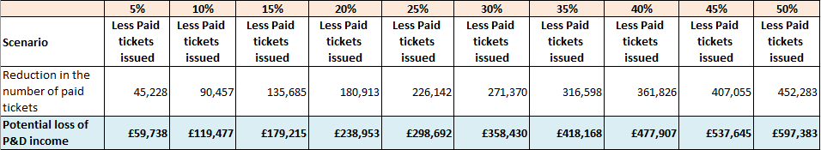
Should the current free parking period be extended to an hour, it is anticipated that the number of free tickets would increase and the number of paid tickets would decrease accordingly. The table below provides a sensitivity analysis of the potential loss of income. This sets out scenarios of 5% to 50% reduction in the number of paid tickets, with the estimated potential loss of income of £60k at 5% increasing to £600k at 50%.

Car Parks
The tickets data and income from car parks are summarised in the table below. An average annual income of around £1.5m was achieved for the 3 year period between 2017/18 and 2019/20.

Average no. of Paid tickets issued | 1,545,324
Average income per Paid ticket | £0.98
Average Total Income | £1,510,024

Should free parking be introduced in car parks, income would be lost for the first hour of parking. The table below provides a sensitivity analysis of the potential loss of income. This sets out scenarios of 5% to 50% reduction in the number of paid tickets, with the estimated potential loss of income of £75k at 5% increasing to £755k at 50%.

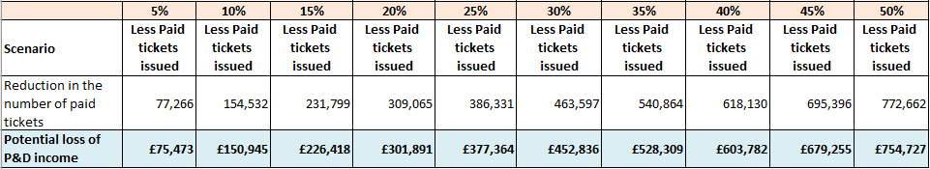
Based on the data above, should the one hour free parking be provided for both on street and car parks, the combined financial impact is estimated at £135k at 5% reduction of paid tickets increasing to £1.355m at 50% reduction.

There would also be a one-off implementation cost of £86k for signage and notice of TMO. These also attract an on-going revenue cost of £5k per annum.

Council Priorities
Thriving economy – this objective will be assisted by assisting local businesses in the recovery from the pandemic by providing a one hour free parkign session for their short term customers on street.

Section 3 - Statutory Officer Clearance
Statutory Officer: Dawn Calvert
Signed off by the Chief Financial Officer
Date: 17th May 2022
Statutory Officer: Hugh Peart
Signed off by the Monitoring Officer
Date: 17th May 2022
Chief Officer: Dipti Patel
Signed off by the Corporate Director
Date: 18th May 2022

Section 4 - Contact Details and Background Papers
Contact: Nicolina Cooper, Interim Head of Traffic, Highways and Asset Management, 07926072600 Nicolina.cooper@harrow.gov.uk
Background Papers: None

